**IOT PROJECT**

(2020-2021)

**IOT based real time covid precaution**

GROUP NO-6

**Midterm REPORT**



**Institute of Engineering & Technology**

**Department of Computer Engineering & Application**

**Team Members**

Mandavi Upadhyaya

(171500178)

Vivek Bhardwaj

(191599019)

Ranjan Kumar

(181500557)

**Supervised By**

Mr. Amir Khan

Asst. Professor

**Department of Computer Engineering & Applications**

**Contents**

1. Acknowledgment

2. Introduction

2.1 Motivation and overview

2.2 Objective

2.3 Scope

3. working model and result analysis

4. Layout

5. some screenshots

6. reason for selecting this project

7. References

**Chapter 1**

**ACKNOWLEDGEMENT**

I have taken efforts in this project. However, it would not have been possible without the kind support and help of many individuals. On the completion of this project I would like to extend my sincere thanks to all of them. I am highly indebted to this project guide **Mr Amir khan**, **Technical Trainer** for their guidance and constant supervision as well as for providing necessary information regarding the project. I wish to extend my sincere gratitude to **Prof. Anand Singh Jalal, Head of** **Department of Computer Engineering and Applications** and faculty of CEA Department of **GLA University** for their guidance, encouragement and give this opportunity and valuable suggestion which prove extremely useful and helpful in completion of this synopsis. I would also like to thank all those who directly or indirectly supported or helped me. I would like to express my gratitude towards my parents and member of my college for their kind cooperation and encouragement which helped me in completion of this project. All of them have willingly helped me out with their abilities.

**Chapter 2**

**2.1 Motivation and Overview**

Internet of Things is a field of technology that describes the network of various “things” that is physical objects that are all embedded with different sensors, that are destined to measure various things or parameters such as temperature, humidity, distance, presence of an obstacle and many more. It also has the ability to transfer over a network using technologies like Cloud computing and fog computing. On such application of iot the covid precaution this was the major issue of now a day the hole world is warried about this disease this help people to prevent yourself.

* 1. **Objective**

The real time covid precaution is an intelligent safety management and monitoring system. The basic objective of this project is made to develop a system model. It monitors and keep a look over the area in which it is installed using sensors

* 1. **Scope**

Since we all are aware that these days covid are rapidly increase the hole world are in danger because any medicine are not there all the people maintain social distancing , sanitizer and many more thing no any time of system keeping this in mind our team has develop an automated and intelligent iot based system which would detect and immediately inform the owner of an unauthorized entry through a real time feedback system giving him the message notification on a mobile application which is a major module of a project.

**Chapter 3**

**Working model and result analysis**

**Working model**

The safety has always become the big necessity for the people. As there are rapid increments in the covid patient.

For the safety purpose of the people to guarding ourself, the system is proposed called “iot based real time covid precaution”.

It reduces the work of human for continuous cheacking of the distance from other people, wear mask and sanitize the hand this system is totally based on take precaution from covid 19.

**In this project so many componets are used**

**ULTRASONIC SENSOR-**

An ultrasonic sensor is an electronic device that measures the distance of a target object by emitting ultrasonic sound waves, and converts the reflected sound into an electrical signal. Ultrasonic waves travel faster than the speed of audible sound (i.e. the sound that humans can hear). Ultrasonic sensors have two main components: the transmitter (which emits the sound using piezoelectric crystals) and the receiver (which encounters the sound after it has travelled to and from the target).

**Ultrasonic sensor working:-**

Ultrasonic (US) sensor is a 4 pin module, whose pin names are Vcc, Trigger, Echo and Ground respectively. This sensor is a very popular sensor used in many applications where measuring distance or sensing objects are required. The module has two eyes like projects in the front which forms the Ultrasonic transmitter and Receiver. The sensor works with the simple high school formula that

Distance = Speed × Time

The Ultrasonic transmitter transmits an ultrasonic wave, this wave travels in air and when it gets objected by any material it gets reflected back toward the sensor this reflected wave is observed by the Ultrasonic receiver module.

Now, to calculate the distance using the above formulae, we should know the Speed and time. Since we are using the Ultrasonic wave we know the universal speed of US wave at room conditions which is 330m/s. The circuitry inbuilt on the module will calculate the time taken for the US wave to come back and turns on the echo pin high for that same particular amount of time, this way we can also know the time taken. Now simply calculate the distance using a microcontroller or microprocessor.

**PIR SENSOR-**

The IR sensor itself is housed in a hermetically sealed metal can to improve noise/temperature/humidity immunity. There is a window made of IR-transmissive material (typically coated silicon since that is very easy to come by) that protects the sensing element. Behind the window are the two balanced sensors.

**How PIR Sensor work:-**

PIR sensors are more complicated than many of the other sensors explained in these tutorials (like photocells, FSRs and tilt switches) because there are multiple variables that affect the sensors input and output. To begin explaining how a basic sensor works, we'll use this rather nice diagram

The PIR sensor itself has two slots in it, each slot is made of a special material that is sensitive to IR. The lens used here is not really doing much and so we see that the two slots can 'see' out past some distance (basically the sensitivity of the sensor). When the sensor is idle, both slots detect the same amount of IR, the ambient amount radiated from the room or walls or outdoors. When a warm body like a human or animal passes by, it first intercepts one half of the PIR sensor, which causes a positive differential change between the two halves. When the warm body leaves the sensing area, the reverse happens, whereby the sensor generates a negative differential change. These change pulses are what is detected.

**Result analysis:**

This project is totally based on covid precaution is device help people to prevent them self from this dangers disease. this device is work on real time they time to time update the user that user is safe or not.

**Layout**

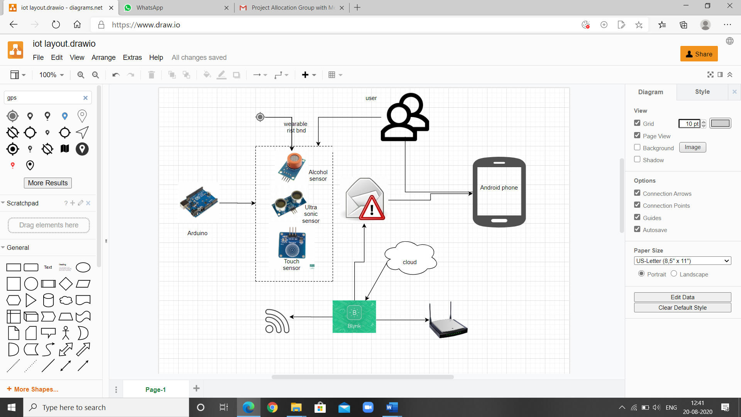

**Some screen sorts**

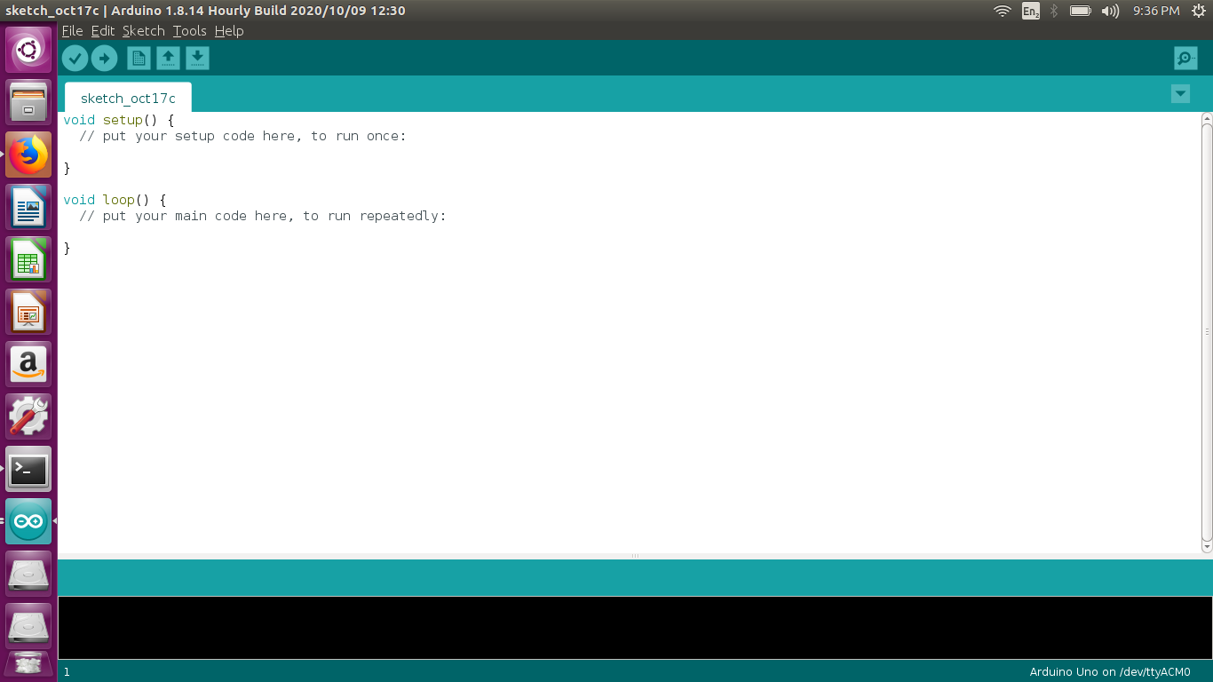

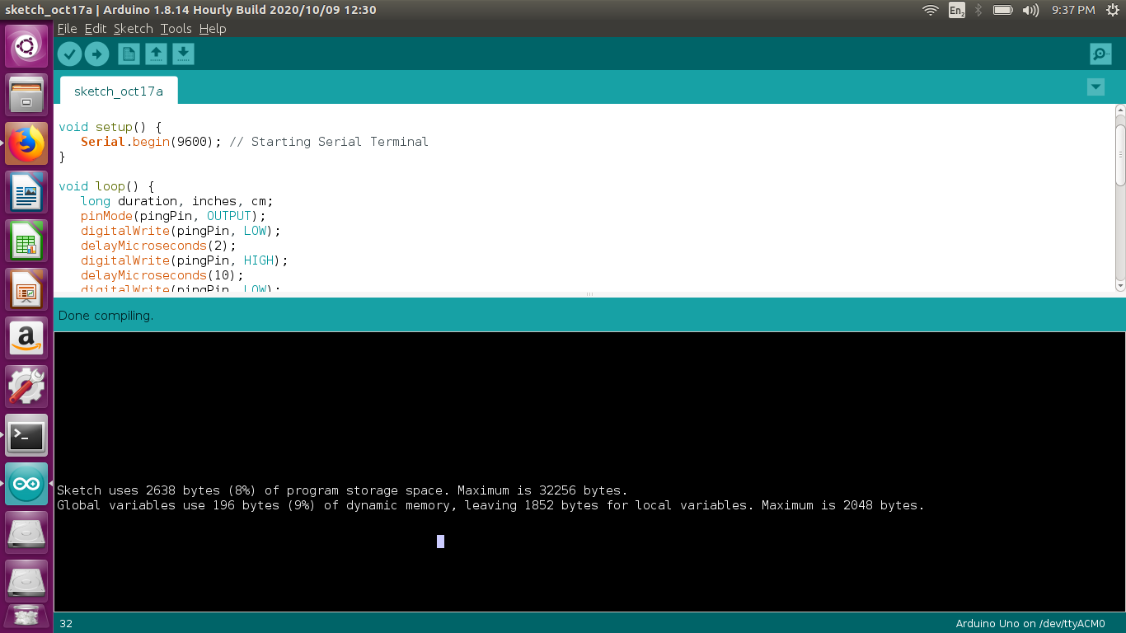

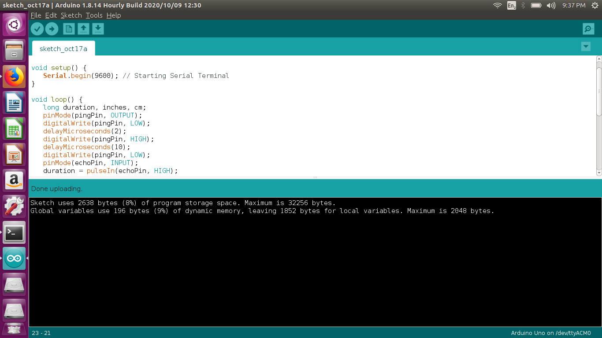

**Code:**

*const int pingPin = 7; // Trigger Pin of Ultrasonic Sensor*

*const int echoPin = 6; // Echo Pin of Ultrasonic Sensor*

*void setup() {*

*Serial.begin(9600); // Starting Serial Terminal*

*}*

*void loop() {*

*long duration, inches, cm;*

*pinMode(pingPin, OUTPUT);*

*digitalWrite(pingPin, LOW);*

*delayMicroseconds(2);*

*digitalWrite(pingPin, HIGH);*

*delayMicroseconds(10);*

*digitalWrite(pingPin, LOW);*

*pinMode(echoPin, INPUT);*

*duration = pulseIn(echoPin, HIGH);*

*inches = microsecondsToInches(duration);*

*cm = microsecondsToCentimeters(duration);*

*Serial.print(inches);*

*Serial.print("in, ");*

*Serial.print(cm);*

*Serial.print("cm");*

*Serial.println();*

*delay(100);*

*}*

*long microsecondsToInches(long microseconds) {*

*return microseconds / 74 / 2;*

*}*

*long microsecondsToCentimeters(long microseconds) {*

*return microseconds / 29 / 2;*

*}*

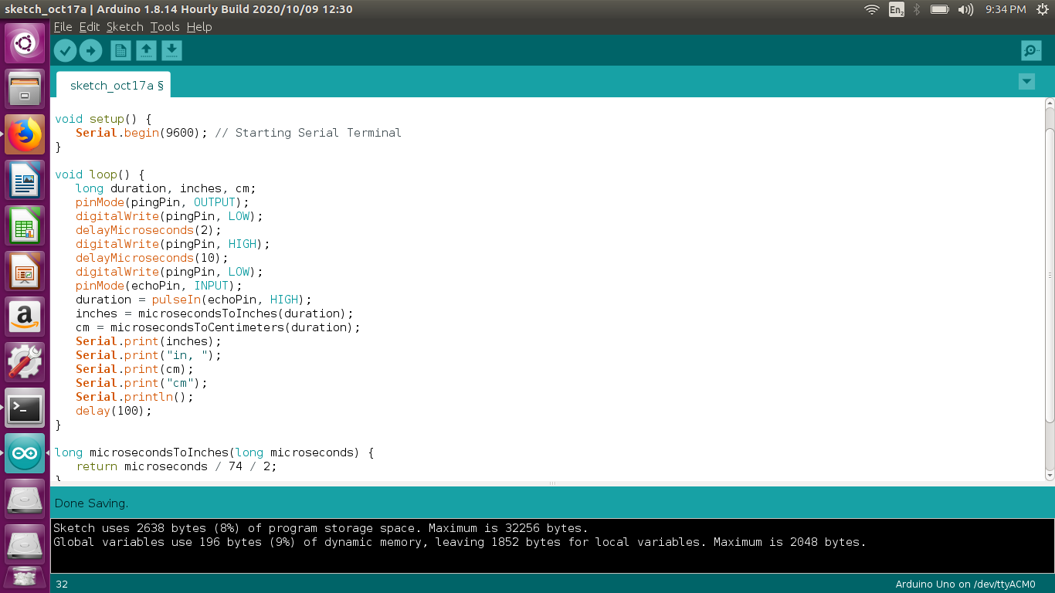

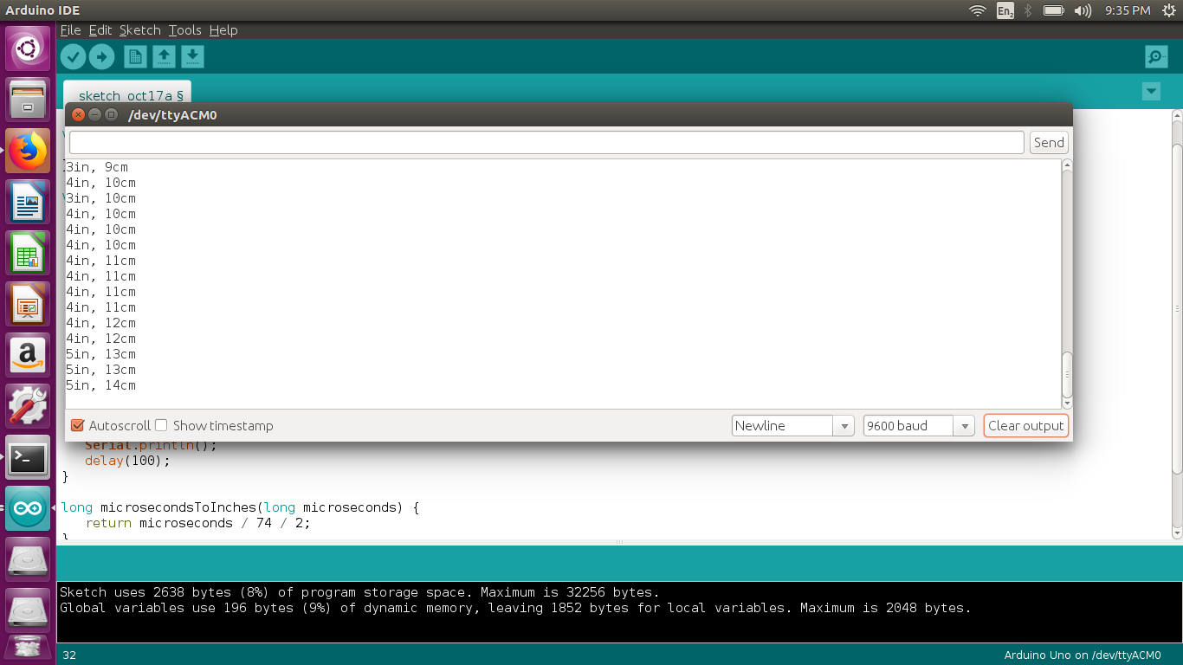

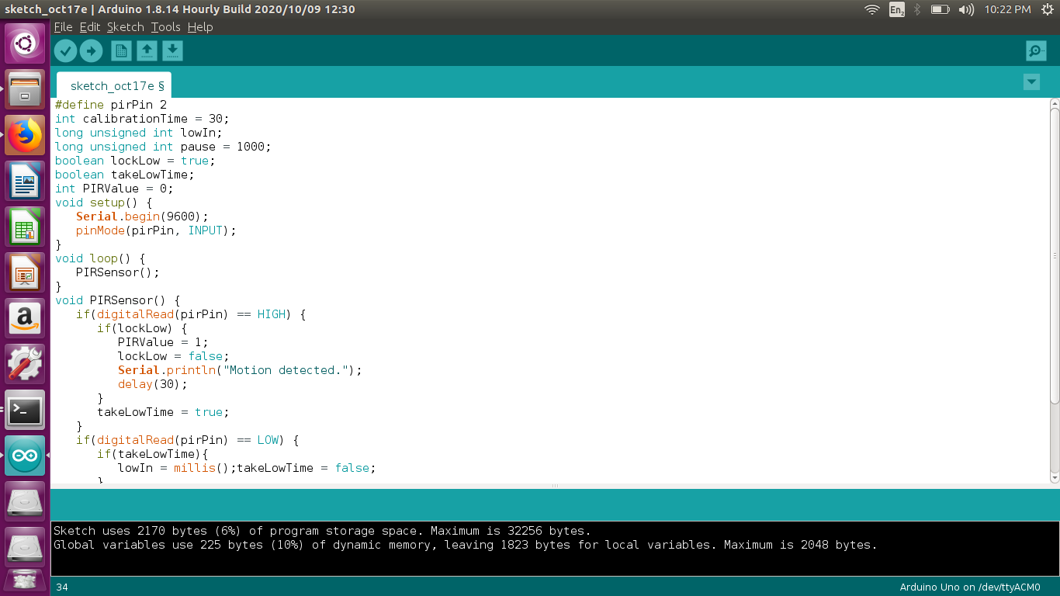

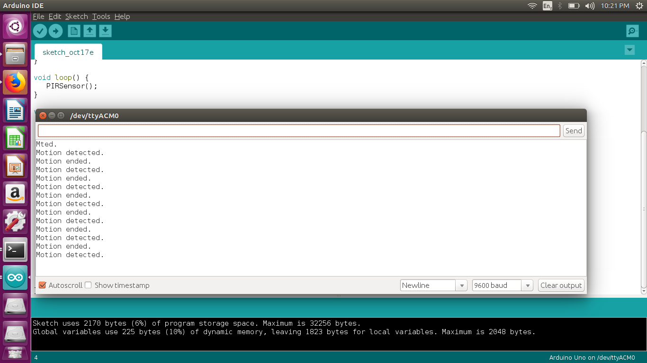

**Code:**

*#define pirPin 2*

*int calibrationTime = 30;*

*long unsigned int lowIn;*

*long unsigned int pause = 5000;*

*boolean lockLow = true;*

*boolean takeLowTime;*

*int PIRValue = 0;*

*void setup() {*

*Serial.begin(9600);*

*pinMode(pirPin, INPUT);*

*}*

*void loop() {*

*PIRSensor();*

*}*

*void PIRSensor() {*

*if(digitalRead(pirPin) == HIGH) {*

*if(lockLow) {*

*PIRValue = 1;*

*lockLow = false;*

*Serial.println("Motion detected.");*

*delay(50);*

*}*

*takeLowTime = true;*

*}*

*if(digitalRead(pirPin) == LOW) {*

*if(takeLowTime){*

*lowIn = millis();takeLowTime = false;*

*}*

*if(!lockLow && millis() - lowIn > pause) {*

*PIRValue = 0;*

*lockLow = true;*

*Serial.println("Motion ended.");*

*delay(50);*

*}*

*}*

*}*

**REASON FOR SELECTING THIS PROJECT:**

The main reason is to select this project because now a days covid are rapidly increase day by day and I feel that is the best, easily understandable and relatable for now condition. My second reason for selecting this is because now a days the iot based gadgets are launched rapidly. this is why choose this.

**References**

1. Tutorial point
2. YouTube

**THANK YOU**